

cOMPOSITION SYSTEM REPLACEMENT

Installation Document



June 22, 2016

GPO Information Technology & Systems

[Company address]

Installation of CSR application on Laptops (ALEX/LEXA)

Contents

Prerequisite 2

Type I (Super Install) 2

XPP Standalone Installation 2

CSR standalone Installation 2

Registry Changes 3

Perl Script 3

Type II 3

CSR standalone Installation 3

Type III 4

Timeline 5

This document explains the process/steps involved in the installation of CSR application in the standalone laptops, which is a replacement of the existing Microcomp application.

# Prerequisite

The installer runs under the assumption that the machines have specified software’s installed.

* Operating system: Windows 7 (Service Pack 1)
* Xmetal with Alex/Lexa.
* .Net Framework version 4.5.
* Adobe Acrobat.

# Type I (Super Install)

Type 1 explains the complete installation of CSR application with the required component of XPP on a standard laptop (LEXA/ALEX). These laptops has the Microcomp installation along with the CSR application.

## Part1 Installation – CSR Prerequisites

XPP installation is completed through CSR-Prerequisites installer (InstallShield project) under “**C:\GPO\”** by default. User has the option to change the directory as they desire on Custom Dialog of CSR-Prerequisites installer by clicking change button.

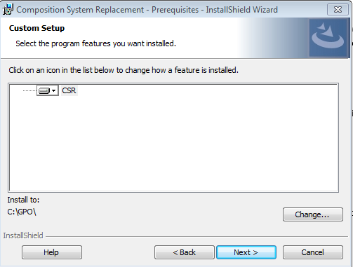

Note: - For CSR-Prerequisites to run successfully it is required to run the CSRSetup.exe as an Administrator.

Once XPP is successfully installed, it requires system to be rebooted. User is presented with an alert after clicking Finish button at the success screen.

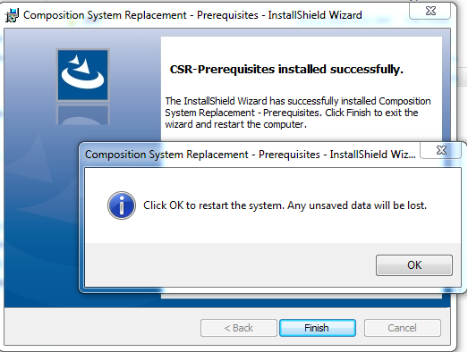

## Registry Changes

Following are the registry changes made by the installer.

Keys Modified:

HKEY_CLASSES_ROOT\Wow6432Node\CLSID\{F8D77580-0F09-11D0-AA61-3C284E000000}\InprocServer32

Keys Added:

HKEY_LOCAL_MACHINE\SOFTWARE\Wow6432Node\USGPO\CSR\InstalledPath

Note: - This section doesn’t include registry changes made by XPP or its components.

# Type II

Type 2 explains installation if CSR application on top of XPP installation. These laptops might have ALEX/LEXA installed. The base version has the windows operating system and the XPP installed already, as we don’t need to install XPP every time. Only CSR related changes or any XPP patches needs are deployed.

## CSR standalone Installation

Application will be installed on C or D drive as follows.

C:\GPO\CSR\ - All the application components go inside the CSR folder including executable.

C:\GPO\CSR\DB - The DB folder has the local database (SQLite)

C:\GPO\CSR\XPP – Currently the XPP folder has GPO Fonts, GPO dictionary items that needs to be installed on the standalone XPP version. Currently these are copied manually from XPP server and passed to packaging. In future, we use web services to get this items from XPP server

<< Describe installation steps with images of screen shot and details what to do on each screen>>

Note:

For part II installation, we are installing on a laptop which has XMetal already installed and no ALEX or LEXA tools present. Similarly XPP is also installed as part of Part I installation.

# Type III

Type 3 is for installing any big fixes and enhancements only. This we can include both CSR application and XPP fixes/patches originating from vendor.

# Timeline



CSR Beta Release in January 1st week

CSR Beta - Pilot run for 4 months along with Microcomp

CSR – Minor Fixes/bugs/enhancement are taken care before the full production run after signoff.